Lemonade

Name __________________________________________

Here are two recipes to make lemonade. The containers are full.
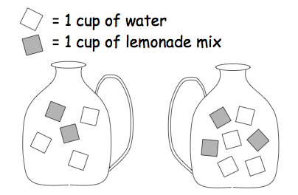
= 1 unit of water
= 1 unit of lemonade mix
Container A Container B

Which container will have the stronger lemonade flavor, or will they taste the same? Explain.

